# Enhancing Spreadsheet Interaction on Interactive Surfaces through Pen-Based Precision Techniques

## 1 Introduction

Spreadsheets are essential tools for organizing data, yet users often encounter input conflicts between grid layers and value layers when operating on interactive surfaces (e.g., tablets, touchscreens). For instance, grid layers intercept most touch events, necessitating cumbersome operations (e.g., multiple clicks) to edit cell content. Furthermore, existing commercial spreadsheet programs exhibit inconsistencies and limitations in designing multimodal interactions (e.g., pen+touch).

This study proposes a novel interaction model by designing precision pen-based interaction techniques, enabling seamless switching between grid and value layers and supporting cross-cell subcontent operations. Its significance lies in enhancing the operational efficiency of spreadsheets on interactive surfaces and providing theoretical foundations for future multimodal interaction designs.

## 2 Related Work

## *2.1 Spreadsheet Interaction*

Research on spreadsheet interaction primarily focuses on improving user efficiency in handling complex tabular data. Early work, such as TableLens, adopted a *focus+context* strategy by embedding data visualization representations to support operations like sorting and filtering, but relied on keyboard and mouse interactions without adapting to touch scenarios. Tableur and WritLarge explored pen-based sketch interactions, allowing users to hand-draw tables and dynamically convert them into structured grids, yet their designs were limited to small informal tables and lacked support for complex operations. TouchPivot introduced basic pen+touch interactions for data filtering and pivoting but failed to resolve input conflicts between grid and value layers.

Pfeuffer et al.’s thumb+pen interaction model proposed task division (pen for selection, touch for manipulation) but remained focused on grid-level operations, neglecting interlayer friction. Other innovations, such as virtual reality (VR) for expanding display space and contactless gestures, enriched interaction modalities but did not directly optimize core spreadsheet editing experiences.

In summary, existing research exhibits gaps in supporting seamless cross-layer interactions (e.g., substring operations, cross-cell batch editing). Commercial software continues to adhere to desktop logic in multimodal design, resulting in layer conflicts and operational redundancy.

## *2.2 Pen + Touch Interaction Techniques*

Research on pen+touch interactions centers on multimodal task division. Early studies (e.g., Brandl et al.) proposed that the pen handles precise input (e.g., writing, selection), while touch manages coarse-grained operations (e.g., navigation, parameter adjustment), validated through efficiency experiments. Hinckley et al. further introduced the *pen+touch = new tool* model (pen for writing, touch for manipulation, combined for advanced functions), widely applied in note-taking and document editing. Subsequent studies expanded the pen’s role: Pfeuffer applied *pen selection + touch manipulation* to spreadsheets, Matulic demonstrated the pen’s efficiency in interface control, and Hamilton utilized pens for precise selection and command invocation in gaming. In data visualization, the pen’s precision supports complex selections (e.g., lassoing, alignment guides), while touch enables multi-finger scaling and layout adjustments. Despite mature task division, recent efforts to integrate additional modalities (e.g., gaze, voice, gestures) face challenges in balancing complexity and user learning costs.

## 3 Methodology

## *3.1 Commercial Software Analysis*

A systematic analysis of commercial spreadsheet programs (Microsoft Excel, Apple Numbers, Google Sheets) across operating systems (Windows, iPadOS, macOS) and hardware (tablets, touchscreens, digital tablets) revealed inconsistencies in input-event mappings (e.g., clicks, drags, two-finger gestures), grid-layer input interception causing layer conflicts, and fragmented logic in modality division. This analysis provided empirical evidence for subsequent optimizations (see Fig.1).

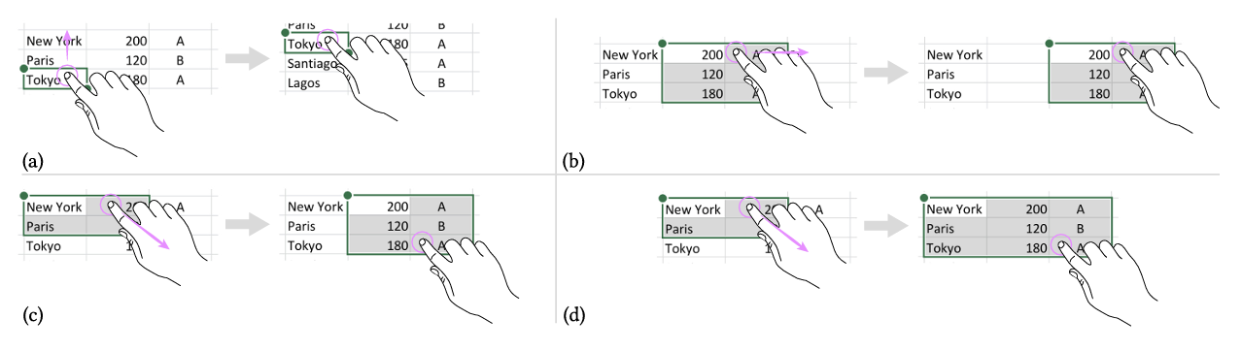

**Fig.1** Four different actions triggered when dragging with a single finger on an already-selected cell

## *3.2 User Needs Survey*

An elicitation study explored user expectations and behavioral patterns for spreadsheet multimodal interactions. Sixteen participants with varied spreadsheet experience proposed gestures for 28 operations (e.g., cell selection, substring deletion, cross-column sorting) and evaluated their intuitiveness via Likert scales. Key findings:

1. Modality Ambiguity: Participants struggled to distinguish grid-layer and value-layer interactions, randomly assigning pen or touch to the same operation. Only complex tasks (e.g., substring deletion) favored the pen’s precision (e.g., lassoing).
2. Natural Gesture Preferences: Users preferred simple markings (e.g., horizontal swipes, circles) for value-layer operations, but lacked consistency.
3. Underutilized Multimodality: Pen+touch synergy was rare (e.g., touch-fixed selections adjusted by pen). Multi-touch proposals were nearly absent, with users relying on single modalities.
4. Pain Points: Cross-layer operations (e.g., multi-column edits) required frequent mode-switching, degrading user experience. Users strongly desired semantic selection (e.g., double-click to match values), unsupported by existing tools.

## *3.3 Interaction Design*

This study proposes a set of spreadsheet interaction techniques designed for interactive surfaces (e.g., tablets, touchscreens), implemented through a web application, to resolve input conflicts among grid layer, numerical layer, and navigation layer operations. The system employs specialized input differentiation: pen tips enable precise selection functionality, supporting cell-level click selection and freeform ink strokes for substring selection, enhanced with semantic extension mechanisms (e.g., double-tap for value matching, triple-tap for full-row selection). Touch gestures exclusively manage layout manipulation, including single-finger dragging for selection movement, two-finger pinch gestures for column structure splitting, and eraser-end operations for cross-hierarchy batch deletion. To address cross-layer operation challenges, a substring generalization algorithm is developed, enabling users to drag selections to column headers for pattern generalization (e.g., batch surname deletion), while simulating word processing logic through click-level semantic extensions (single-click positioning to triple-click paragraph selection).

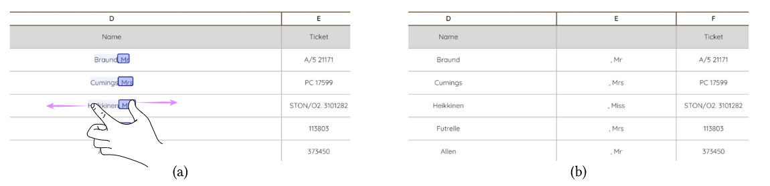

**Fig.2** Splitting title and surname in two separate columns.

Navigation optimization introduces two dedicated tools (Fig.3): Minitable facilitates cross-region row/column dragging through thumbnail previews and brush selection, coupled with touch gestures for long-distance data reorganization. Minivis implements visual selection filtering based on data distribution characteristics (bar charts for categorical data/density plots for numerical data), enabling direct pen-based selection of specific numerical ranges (e.g., outliers or quartiles). Additional functionalities include handwriting recognition and layout transformation, supporting quick-access formula windows via short pen gestures, real-time correction through erase gestures, and complex data restructuring (e.g., date splitting and name inversion) through coordinated pen dragging and touch-based pinch gestures. Implemented in a prototype system, these techniques aim to transcend traditional spreadsheet hierarchy limitations by simplifying data exploration and editing workflows through direct manipulation paradigms.

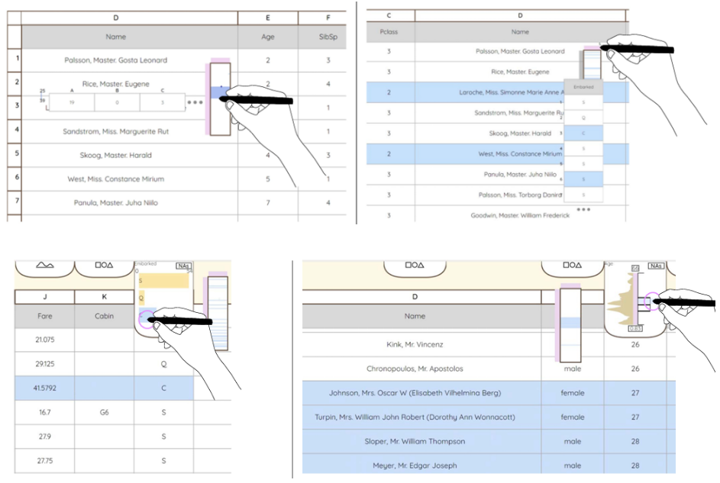

**Fig.3** Minitable and Minivis tools

## 4 Experimental Results

Semi-structured user testing (six participants performing open-ended tasks) validated the framework:

1. Basic Operations: Two-finger navigation and eraser deletion achieved 85% satisfaction. Semantic selection (double/triple-click) improved efficiency (usability score: 4.83/5, Fig.4).

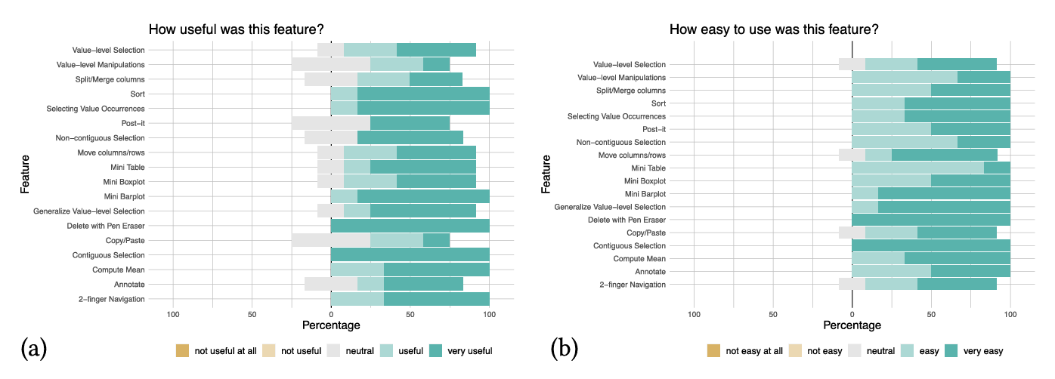

**Fig.4** Participants’ evaluation of (a) usefulness and (b) ease-of-use for 18 interactive features using 5-point Likert scales.

1. Value-Layer Operations: Users successfully employed substring generalization to accomplish complex data reshaping tasks (e.g., date splitting, numerical format unification), with gesture-driven case switching and multi-selection synchronous editing functionalities receiving particular acclaim. Although initial limitations existed in cross-cell heterogeneous editing, the improved multi-cursor placeholder design effectively addressed this issue, validating the feasibility of direct manipulation in syntax transformation scenarios.

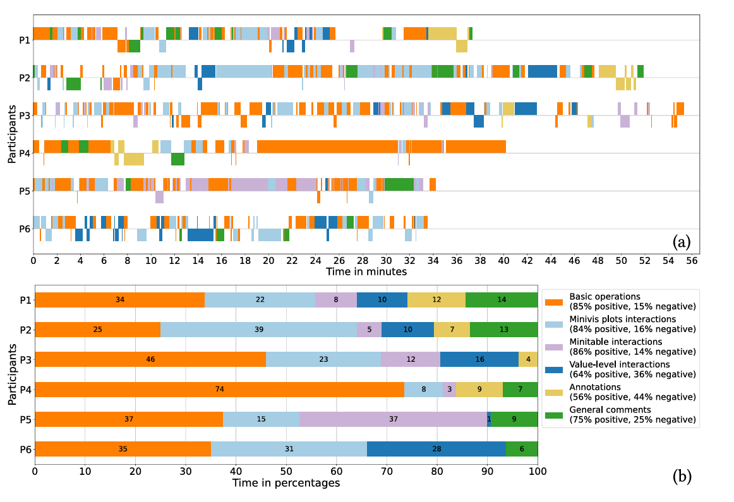

**Fig.5** (a) Interaction sequences of the think-aloud phase, with one timeline track per participant. (b) Relative time spent performing interactions of different types, per participant.

1. Navigation Tools: Minitable and Minivis enhanced data exploration; 80% of participants used thumbnail previews and visual filtering for cross-dataset analysis. Notably, Minivis’s outlier screening and quartile selection features were frequently employed by P2-P5 (Fig.5) for data hypothesis validation.
2. Annotation Conflicts: Despite achieving a usability score of 4.5, 44% of negative interactions highlighted display conflicts between the annotation layer and the navigation layer. In particular, the *global visibility of annotations* requirement proposed by P4 revealed potential improvements in the current layer management mechanism.

Overall, the experimental results demonstrate that the novel interaction techniques effectively transcend the hierarchical limitations of traditional spreadsheets, providing information workers with a data manipulation paradigm that better aligns with cognitive habits.

## 5 Summary and Future Directions

This study addresses the hierarchical overlay conflicts in spreadsheet operations on interactive surfaces by proposing a stylus-touch collaborative interaction framework. Through a multimodal division-of-labor model (*stylus + touch*), the system leverages the spatial-context recognition capabilities of stylus input to implicitly distinguish between grid-layer and value-layer operations, overcoming the operational ambiguity caused by traditional interface hierarchy overlaps. By integrating commercial software analysis, user heuristic exploration, and semi-structured experimental validation, the research team demonstrated the model’s effectiveness in supporting cross-layer selection, semantic editing, and navigation optimization. Key innovations—such as cross-column operations via substring generalization algorithms, distribution-based filtering with visualization plugins, and direct editing through handwritten formula recognition coupled with erase gestures—significantly enhanced the fluidity of complex data processing.

Future research should focus on three directions: First, expanding the direct manipulation paradigm to advanced data transformations (e.g., dynamic pivoting, conditional formatting), exploring natural linkages between stylus-based selections and formula generation (e.g., mapping substring operations to text function expressions). Second, developing novel interaction grammars for non-handheld devices, integrating auxiliary modalities like gaze tracking and gesture recognition to establish spatialized operation paradigms on large-scale interactive surfaces. Third, balancing technological innovation with user inertia by designing progressive learning paths for expert users, transforming low-frequency complex operations (e.g., data folding/reorganization) into discoverable interaction patterns while preserving the intuitiveness of basic operations. As flexible screens and pressure-sensitive styluses become mainstream, integrating physical interface characteristics into spreadsheet metaphor design may emerge as a critical breakthrough for next-generation data interaction.

## 6 Reflections

Traditional spreadsheet software struggles with hierarchical overlap and input conflicts on interactive surfaces, leading to suboptimal user experiences. This research introduces stylus-based precision interaction, resolving these issues while offering more intuitive and efficient workflows.

In human-computer interaction, the untapped potential of multimodal interaction is evident. The stylus-touch collaboration model provides a novel framework not only for spreadsheets but also for data-intensive applications like visualization and graphic editing tools. Advances in hardware—such as flexible displays and pressure-sensitive styluses—will unlock further innovations. For instance, integrating haptic feedback and voice control could elevate user experiences.

Central to interaction design is a deep understanding of user needs. This study exemplifies how user-centric research—via surveys and experiments—translates requirements into actionable interaction techniques. Future work should incorporate user behavior analytics, leveraging big data and machine learning to predict user intent and deliver intelligent interaction support.

Finally, optimizing user education and learning curves is critical as interaction complexity grows. Context-aware prompting systems could offer real-time guidance, reducing cognitive load. For example, just-in-time tutorials might help users master advanced features like data folding.

In conclusion, interaction design transcends technological advancement; it demands empathy for user needs. By refining multimodal techniques and integrating behavioral insights, future designs will deliver seamless, efficient, and cognitively aligned experiences.

## Reference

Cavez, Vincent, et al. “Spreadsheets on interactive surfaces: Breaking through the grid with the pen.” ACM Transactions on Computer-Human Interaction, vol. 31, no. 2, 29 Jan. 2024, pp. 1–33, [https://doi.org/10.1145/3630097.](https://doi.org/10.1145/3630097. )